**Get data**

In this demo, you use **Get Data** to connect to the AdventureWorksDW sample database, select data, preview and filter, and then import into your model workspace.

By using Get Data, you can import data from a wide variety of sources. Data can also be queried using a Power Query M formula expression or a native SQL query expression.

## **Create a connection**

* In **Tabular Model Explorer**, right-click **Data Sources** > **Import from Data Source**. This launches **Get Data**, which guides you through connecting to a data source. If you don't see Tabular Model Explorer, in **Solution Explorer**, double-click **Model.bim** to open the model in the designer.

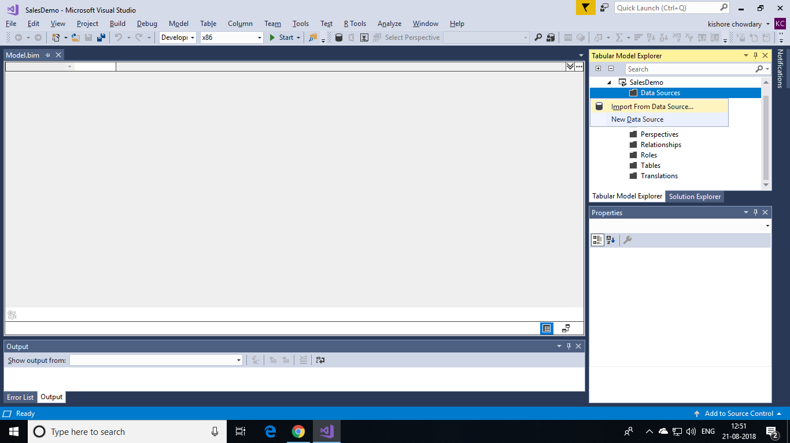

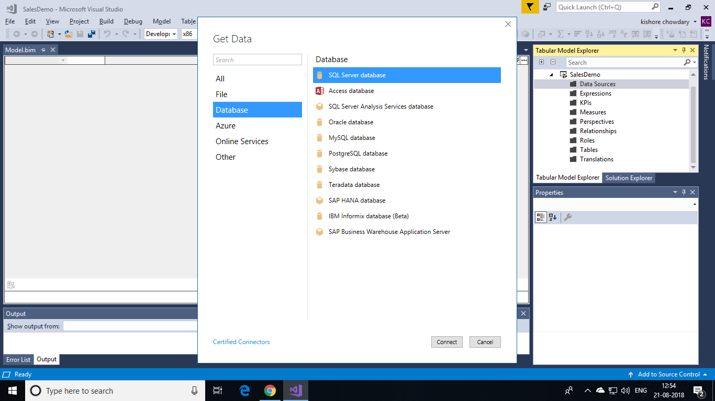

* In Get Data, click **Database** > **SQL Server Database** > **Connect**.
* In the **SQL Server Database** dialog, in **Server**, type the name of the server where you installed the AdventureWorksDW database, and then click **Connect**.

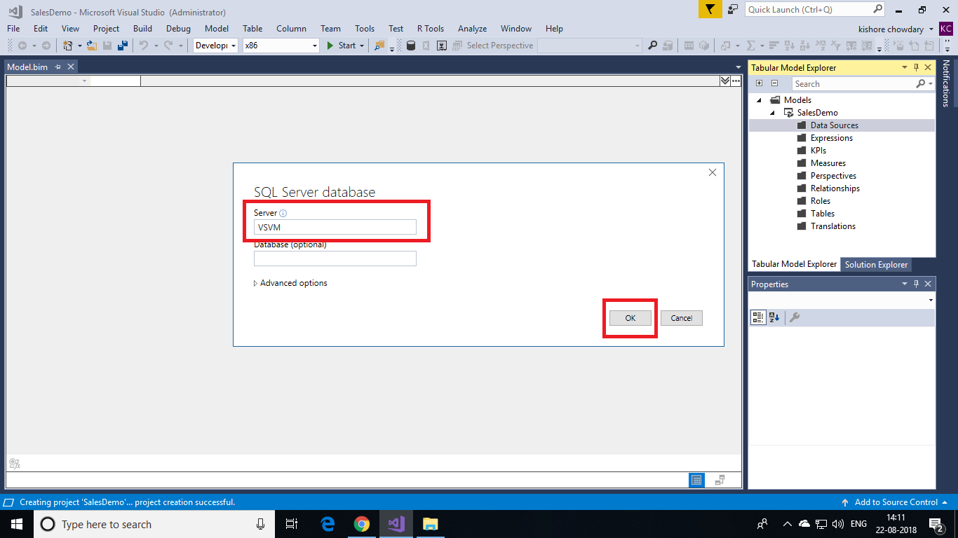

* When prompted to enter credentials, you need to specify the credentials Analysis Services uses to connect to the data source when importing and processing data. In **Impersonation Mode**, select **Impersonate Account**, then enter credentials, and then click **Connect**. It's recommended you use an account where the password doesn't expire.

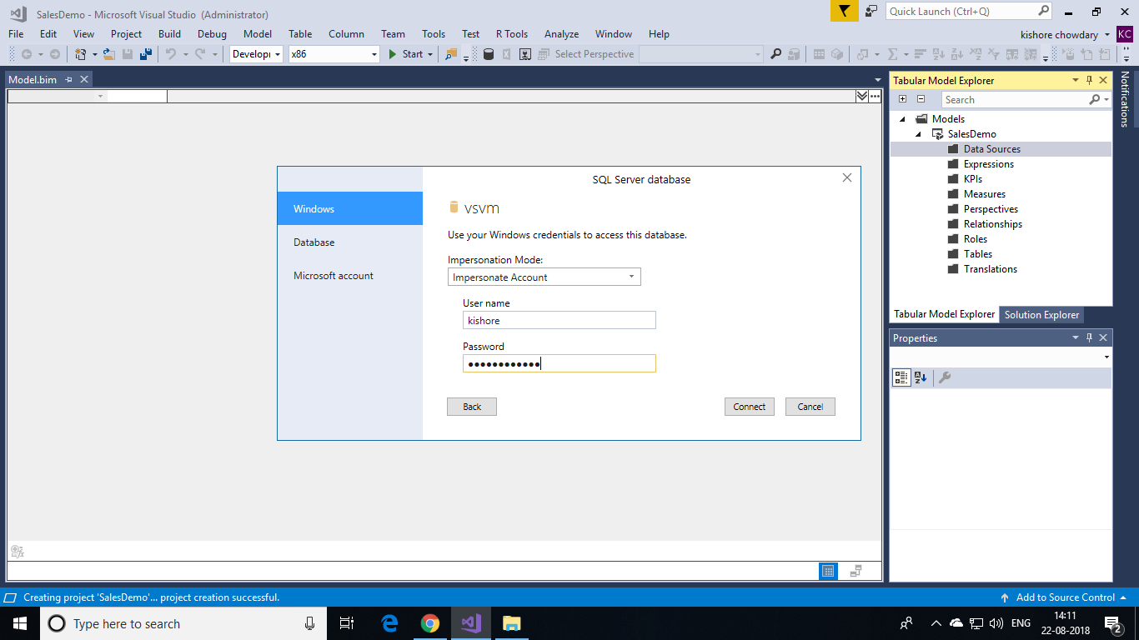

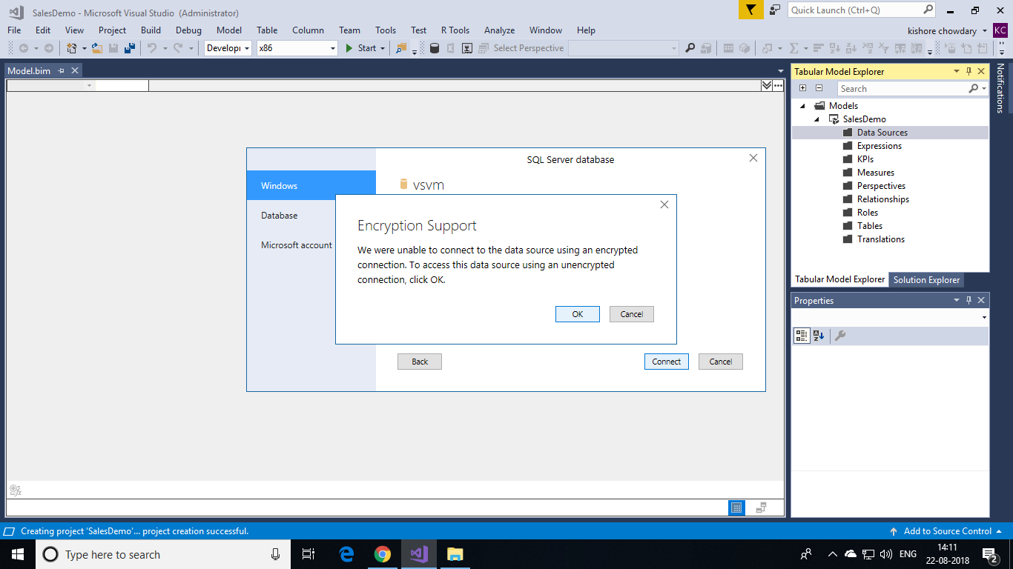

* In Navigator, select the **AdventureWorksDW** database, and then click **OK**. This creates the connection to the database.

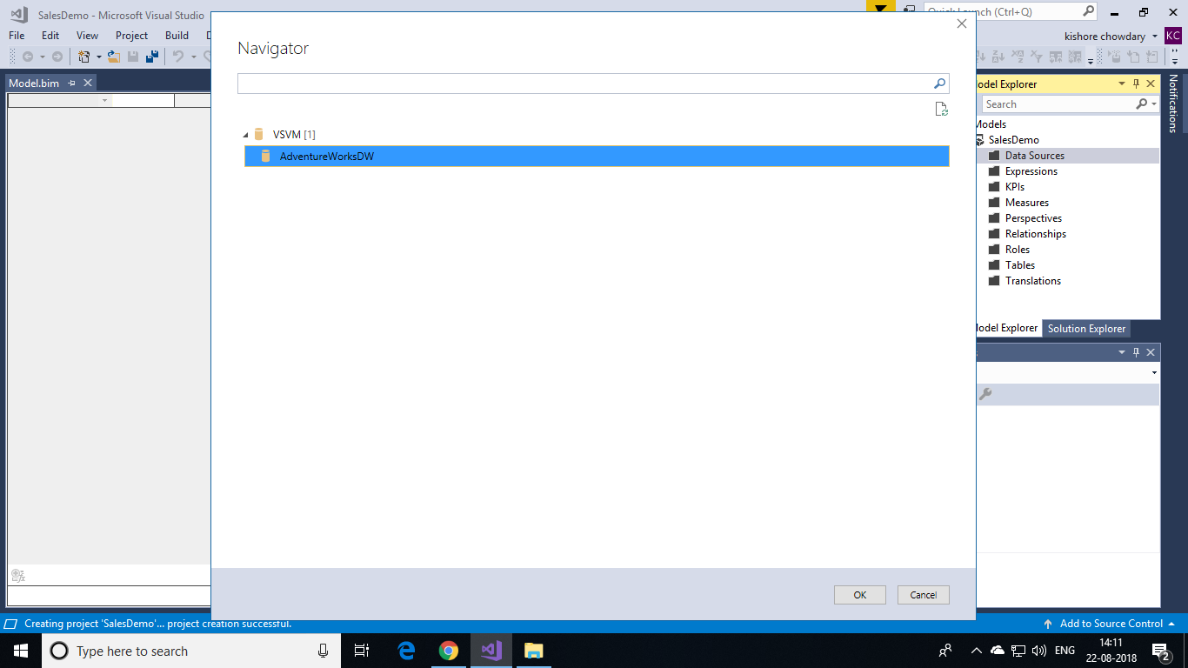

* In Navigator, select the check box for the following tables: **DimCustomer**, **DimDate**, **DimGeography**, **DimProduct**, **DimProductCategory**, **DimProductSubcategory**, and **FactInternetSales**. Then click **Load** button to load data into the project.

